Using the application
The system is based on weekly reporting of System Testing and RTS. Every week starts on a Sunday and ends on Saturday. Each performance metric has a target value above which it will be displayed in green, below target is red and gray represents no data.
There are two main screens, one to view the data and one to add or edit the information. The system will ask for some access permissions during the first launch, after that it will know for which plant to display the information. You will only be able to see, add or edit your plant's data.
Main Screen
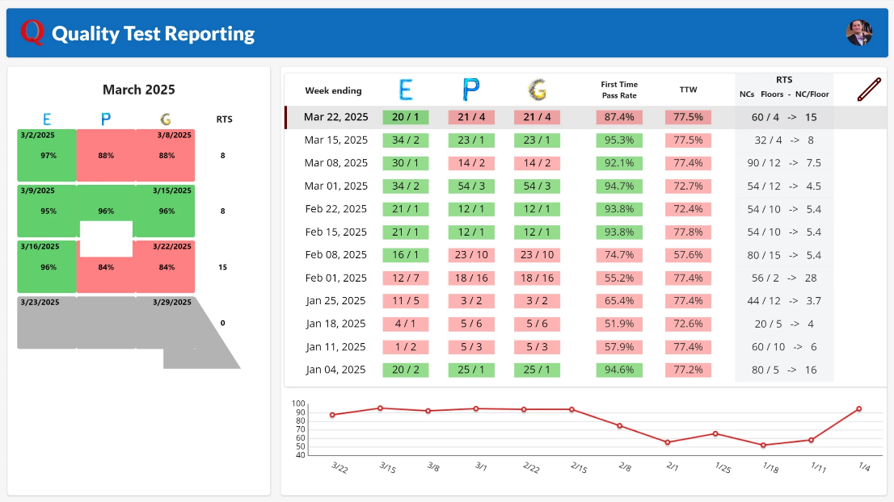
The main screen contains the letter Q divided horizontally into the number of weeks in the current calendar month, vertically it has the Electrical, Plumbing and Gas metrics for your facility as reported. The RTS column displays the non-conformities per floor found that week.
Click on the red pencil near the top right to enter new data or edit values by accessing the second screen.

Data Screen
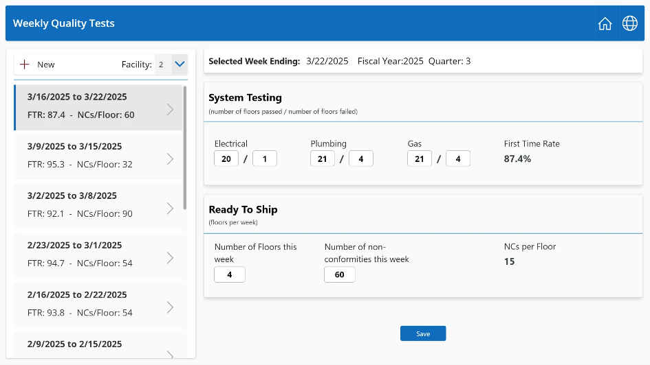

Select your Facility number and click the plus icon next to New to add a record.
For every week the system tracks the number of floors passed and failed for Electrical, Plumbing and Gas tests. In RTS report the total number of floors inspected during the week and the number of non-conformities during the same week.
Click Save when done. You will be able to edit the data within 24 hours of entering it, after that it will be locked to prevent changes.
The information entered by the plants will feed into a larger report with filters. This will empower plants to not only track their quality performance to seek improvements but also compare to other plants that may be similar in output and floor models.

